

Behaviour and Relationships Policy

INTRODUCTION
At St. Paul’s we are committed to enabling all children to access education successfully and believe all members of our community have a voice. As part of our Catholic ethos within school we are committed to establishing high standards of behaviour and positive relationships.

We are an inclusive school and we promote our key values of kindness, respect and resilience, which is thread across all aspects of school life. These values support our Mission Statement of:

Learning from the example of Jesus, our school will be a place where everyone feels loved, valued and encouraged to be and do the best they can.

We aim at all times:
To create an atmosphere where children are able to develop a moral awareness and are empathetic towards the needs of others within our community, nationally and globally with specific links to the importance of social justice and conservation.

To notice and praise positive attitudes to behaviour and work and to maintain fairness and consistency, whilst encouraging self-regulation.

We recognise that high standards are best promoted when everyone (staff, parents and children) have a shared understanding of what is acceptable and unacceptable behaviour.

By promoting good behaviour we can build individual and collective esteem and encourage good personal relationships.

PRINCIPLES
- Every child has the right to learn but no child has the right to disrupt the learning of others.
- Everyone has a right to be listened to, to be valued, to feel and be safe.
- We celebrate diversity and we are a LGBTQ+ safe environment.

IMPLEMENTATION
It is recognised that the quality of learning experiences in the classroom will have an impact on behaviour. High expectations from staff delivering a curriculum matched to children's varying needs will help to motivate pupils promoting self-esteem and confidence, leading self-discipline. Good behaviour does not happen by accident. It needs to be modelled, coached, revisited, reinforced, reviewed and adaptable to circumstances and changing situations within daily life. Children need supporting in making appropriate choices in how to behave in different situations.

IN ALL DISCIPLINARY ACTIONS IT IS ESSENTIAL THE CHILD KNOWS THAT IT IS THE BEHAVIOUR WHICH IS UNACCEPTABLE, NOT THE CHILD AS A PERSON.

THE ROLE OF THE HEADTEACHER & SLT
It is the role of the Headteacher, to implement the school Relationships Policy consistently throughout the school, and to report to Governors, when requested, on the effectiveness of the policy. It is also the responsibility of the Headteacher to ensure the health, safety and welfare of all the children and staff in the school.

The Headteacher supports the staff by implementing the policy, by setting the standards of behaviour, and by supporting staff in the implementation of the policy.

The Headteacher has access to records of all reported incidents of poor behaviour in our incident book within school (refer to CPOMS).

The Headteacher has the responsibility for giving fixed-term suspensions to individual children for serious acts of misbehaviour. For repeated or very serious acts of anti-social behaviour, the Headteacher may permanently exclude a child. Both these actions are only taken after seeking advice from the Local Authority and the School Governors have been notified.

THE ROLE OF STAFF MEMBERS
Staff members treat each child fairly and enforces the Staff Code of Conduct consistently. All adults treat all children in their class with kindness, respect and understanding.

It is the responsibility of all staff members to record significant incidents of inappropriate behaviour on CPOMS.

Schools have statutory authority to discipline pupils whose behaviour is unacceptable, who break the school rules or who fail to follow a reasonable instruction.

The class teacher reports to parents about the progress of each child in their class, in line with the whole-school policy.

FAMILY INVOLVEMENT
Staff welcome early contact if parents / carers have a concern about their child’s behaviour or fear that they are being upset by others. At St. Paul’s we have an open door policy and parents are welcome to come into school at the beginning of the day or after school to discuss any matters with the class teacher (where appropriate) or a member of SLT. If parents and school work together we believe that the discipline and behaviour of pupils will be maintained and respected by all.

WORK MATCHED TO NEEDS / PROMOTING SELF ESTEEM
We aim for all pupils to access age related content as far as possible. Fluid scaffolding based on teacher assessment from day to day enables us to do this. Scaffolding is subtly removed over time to encourage independence. Scaffolding may take the form of using equipment, adult/peer support, vocabulary mats/reference materials, sentence stems or voice recording (amongst other approaches). A record of work may take a variety of forms over time, such as books, photographs, videos and voice notes. Pupils will be encouraged to present their understanding in a variety of formats, as we value learning above ‘task completion’.

STRATEGIES
In order to assist with the implementation of our discipline policy, staff should:
- Aim to be good role models.
- Never walk past ignoring poor behaviour: Stop – Notice – Support – Move on.
- Remind children, as they leave classes, of expected behaviour when moving around school i.e. walking in single file - no running.
- Encourage group games in the playground, placing emphasis on taking turns.
- Use key words for reinforcement e.g. kindness, respect, resilience.
- Praise individuals, groups, classes as and where appropriate.
- Involve outside agencies where necessary through consultation with the SENDCO

PUPIL CONDUCT OUTSIDE THE SCHOOL GATES
Schools have a statutory legal power to regulate the behaviour of pupils on trips and visits, and when travelling to and from school. Failure to follow the Relationships Policy in these circumstances will also result in appropriate consequences from school.

CONFISCATION OF INAPPROPRIATE ITEMS
Staff have the right to confiscate a pupil’s property which is prohibited on the premises and this is a disciplinary consequence. Confiscated items will be kept in a secure place by the teacher or the office. Please see our Search and Confiscation Policy on the school website.

USE OF REASONABLE FORCE
School staff have a legal power to use force and lawful use of the power will provide a defence to any related criminal prosecution or other legal action. Please see our Physical Intervention Policy on the school website.

REWARDS
We aim to reward positive rather than emphasise negative attitudes to behaviour and work. It is important to keep this philosophy in perspective. For the majority of children this approach will work, sanctions should be needed only for a minority of children.
It is essential that the main focus for rewards and sanctions should be within the classroom, extending to SLT where necessary. They should be applied in a fair and consistent manner with appropriate parental involvement.

Rewards can include the following:

- Verbal praise e.g. to the child, parent, another adult in school
- Merit points, stickers certificates for academic and non-academic achievement
- Hot Chocolate Friday
- Wrist bands (kindness, respect. resilience)

REPAIRING CHALLENGING BEHAVIOUR

School staff work through these five guidance steps (see policy blueprint):
- REMIND
- CAUTION
- CALM / SPACE TO REGULATE
- RESTART
- REPAIR & REFLECT LATER

Further Support
In addition, the class teacher can seek the involvement of the SLT and / or the Headteacher. The Headteacher can follow up by:
- Asking parents to escort children to and from the premises before and after school, on safety grounds
- Ask parents to supervise them at home during lunchtimes
- Fixed exclusion; indefinite exclusion or permanent exclusion*

*Exclusions will be carried out in accordance with LA policy and Governors directive and be used in only the most serious cases.

STAGES OF INTERVENTION
The school’s discipline procedures can be summarised into six stages. The context of each individual should always be taken into consideration.

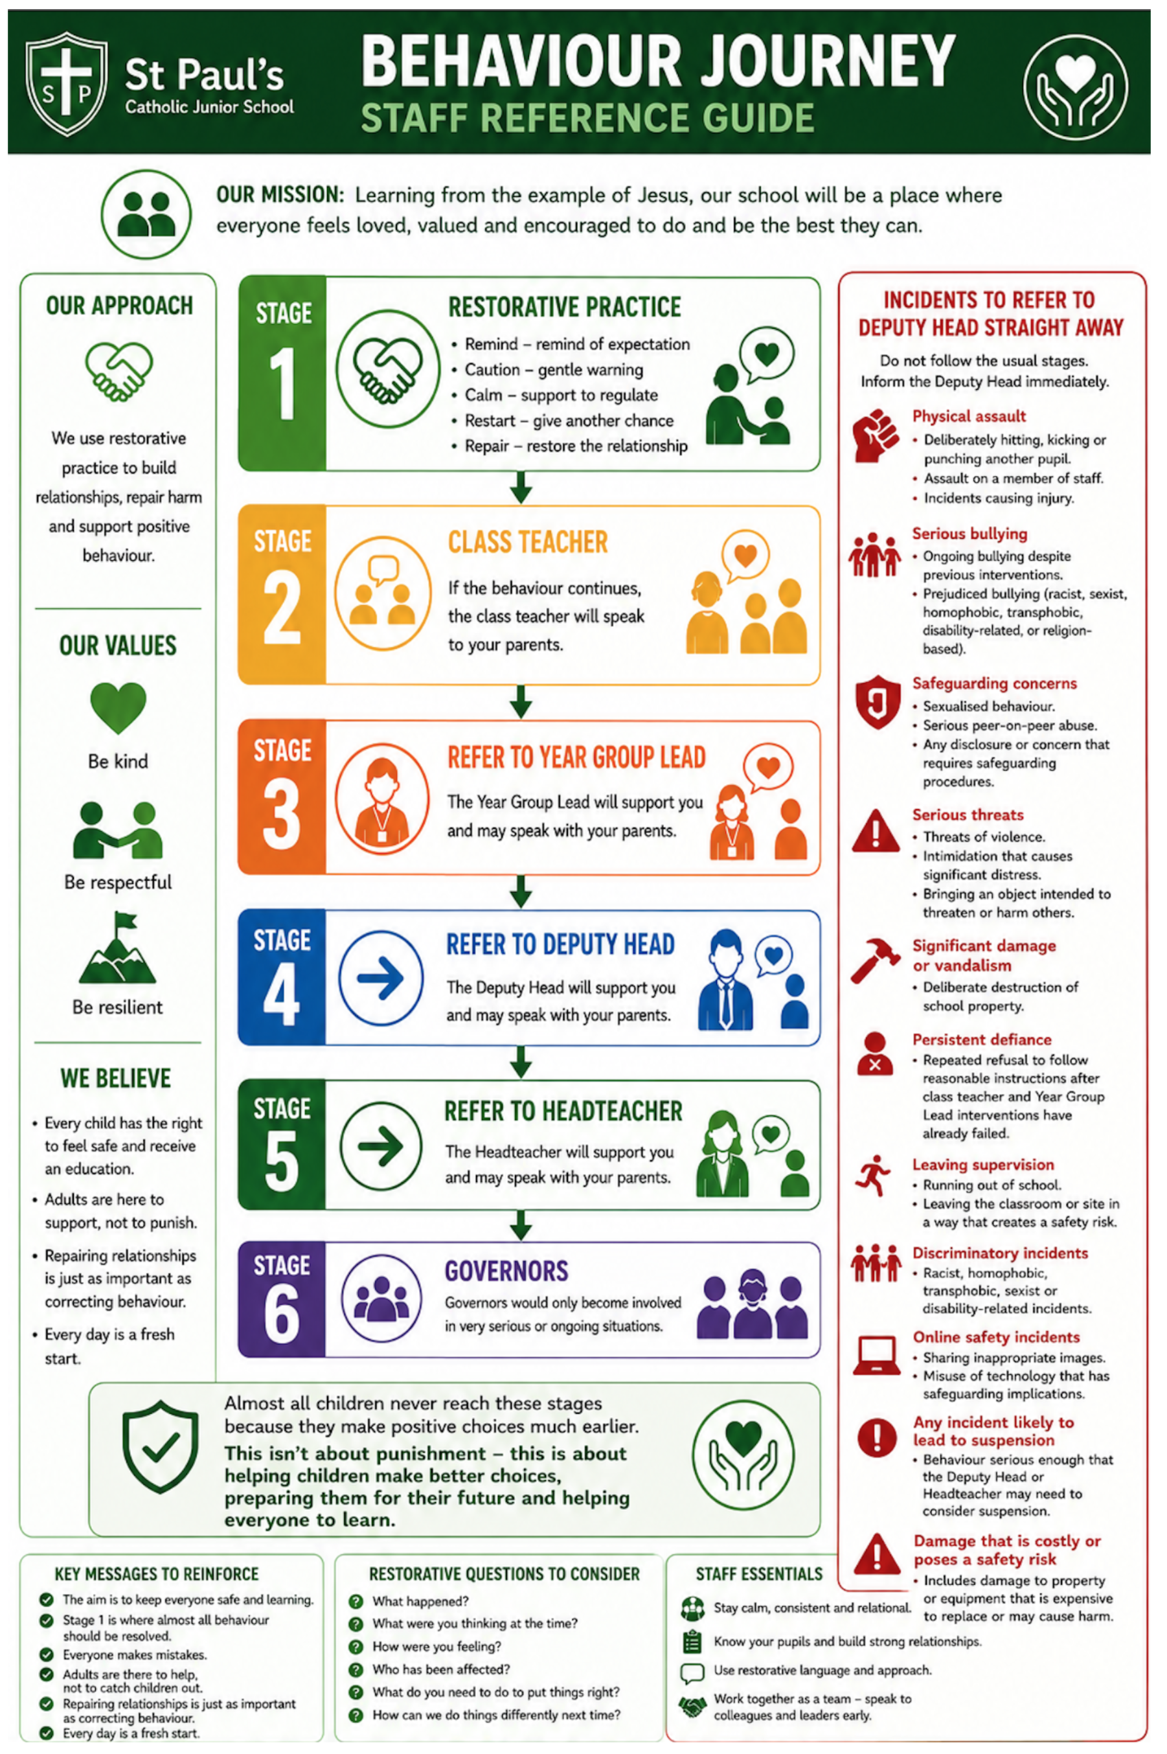

For repeated low-level behaviour incidents, the class teacher may decide that a pupil needs to miss part or all of a break time to reflect and reset.
Class teachers will seek parental support for behaviour improvement before referring to year group leads.
If the behaviour continues and the pupil is referred to the Year Group Leader (YGL), the YGL may decide to introduce a Home Link Book. Where this is implemented, parents should be informed and the purpose and expectations explained. Home Link Books should be used for a fixed period (for example, two weeks), after which their impact should be reviewed with the pupil, parents, and class teacher to determine the next steps.

